CERTIFICATE OF CONFORMITY TO OEM REFERENCE

Juratek Product Reference | VOL113
Product Description | Brake Disc
OE Part Number | 85103804,5001867798
Application(s): | Volvo FH, FM series
Application(s): | Renault Magnum DXi12, DXi13 ; Premium Dxi
Supplier Quality Approval | BS EN ISO9001: 2008

We certify that the goods detailed above conform to the material & dimensional specifications required by Juratek Ltd and that they are fit for direct OEM replacement.

Print Name: | Andrew Kibler
Signed: | 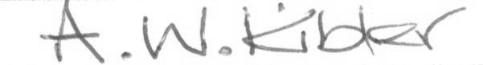
Position: | Quality & Engineering Manager
Date: | 31 July 2026

